Instructions for Acknowledging Course Assignments
through Faculty Load and Compensation (FLAC)

These instructions will guide you through the process of acknowledging your summer or overload assignment. This process is necessary to make sure you receive payment. If your teaching assignment changes after you have acknowledged, you will receive an email to acknowledge your revised assignment.

Step 1: From the www.mscc.edu homepage, log on to My Motlow.

Step 2: Click on the Employee Tab

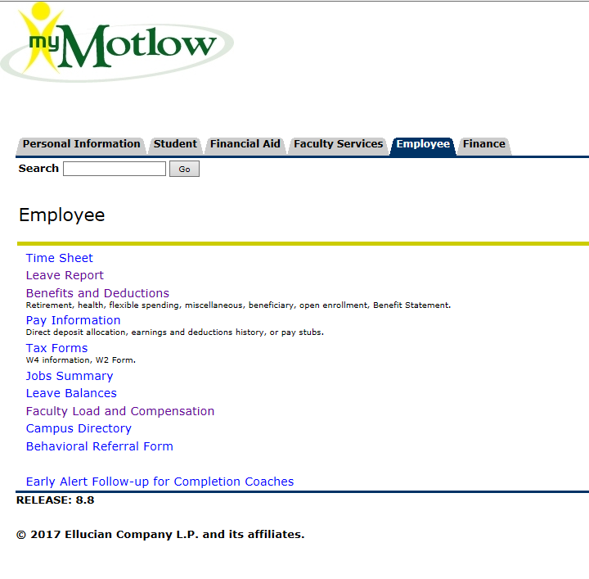

Step 3: Click on Faculty Load and Compensation
Step 4: Click on Compensation and Acknowledgement

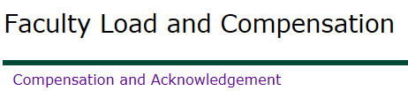

Step 5: Choose the current term and click Go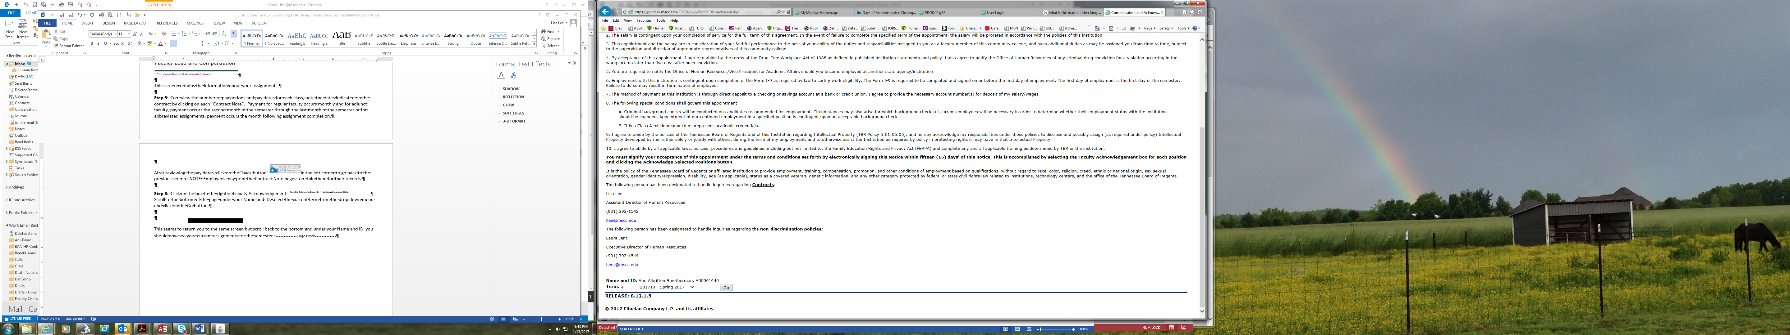

This screen contains the information about your assignments.

Step 6: To review the number of pay periods and pay dates for each class, note the dates indicated on the contract by clicking on each “Contract Note”.

After reviewing the pay dates, click on the “back button” 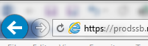in the left corner to go back to the previous screen. NOTE: Employees may print the Contract Note pages to retain them for their records.

For regular faculty, payment occurs monthly and for adjunct faculty, payment occurs the second month of the semester as specified on the Contract Note through the last month of the semester and for some abbreviated assignments, payment may occur the month following assignment completion.

Step 7: Review each teaching assignment
Click on the Contract Note button to see the specific contract language for this contract type.
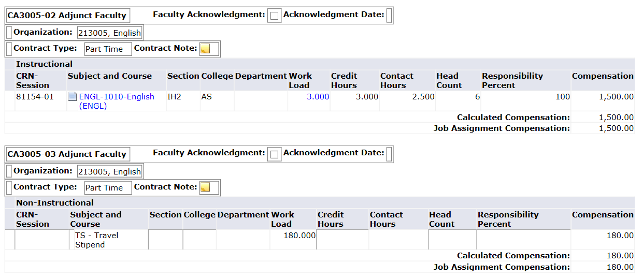

Each contract type has language specific to the contract. For Example: There is a different Contract Note for
Part Time (PT), No Pay (NP), Overload(OV), Summer (SU), etc.

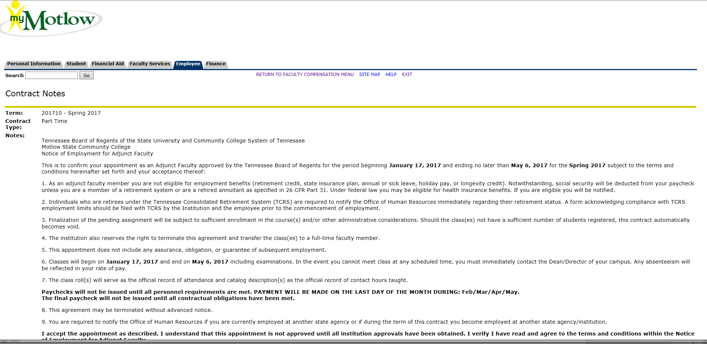
Click on the paper icon for detailed course information.

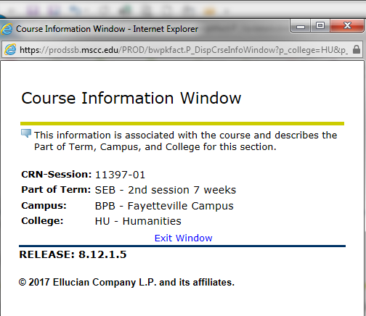

Step 8: If your contract information is correct, click the box to the right of “Faculty Acknowledgement”. Acknowledge each course and stipend as applicable.
Course CRN, Title and Section
If your schedule qualifies for a travel stipend you will see it here.

Step 9: Click “Acknowledge Selection Positions”
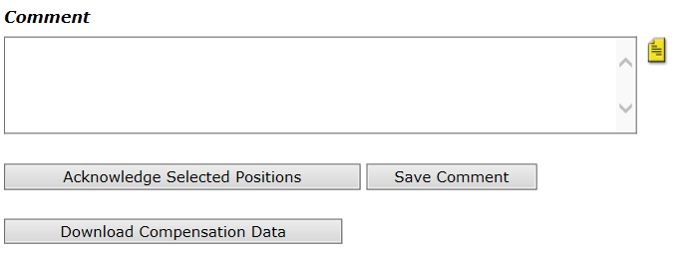
NOTE: Your comments are not sent out and are not accessible to be reviewed by Administration.

Step 10: After acknowledging your teaching assignments you will see a message saying “Your change was saved successfully.” Each class you acknowledged will have a check mark and the date that you acknowledged the assignment and the acknowledgment date appears.
IMPORTANT: Remember, you will receive an email each semester when your contract is ready to be acknowledged. If your class assignment changes, you will receive an email asking you to acknowledge the change.
If you have questions about this process or need additional assistance, please contact Lisa Lee, Assistant Director of HR at llee@mscc.edu or phone 931-393-1542. You may also contact Stacy Hearn, Executive Secretary at shearn@mscc.edu or 931-393-1698.

